March 11, 2024
Ref: IIH/MD/2024/03/009

IHS Nigeria,
Plot 934, Idejo Street,
Victoria Island, Lagos,
Nigeria.
Attn:
Salim Sasidharakurup
Senior Analyst, Procurement

Dear Sir,

CORPORATE BANK DETAILS FOR THE ILORIN INNOVATION HUB LTD
I write to convey the details of the corporate bank account for the Ilorin Innovation Hub Ltd which we maintain with Premium Trust Bank.
Account name: Ilorin Innovation Hub Ltd
Account Number: 0040117676
Account Type: Corporate Current
Sort Code: 105190139

Yours sincerely,
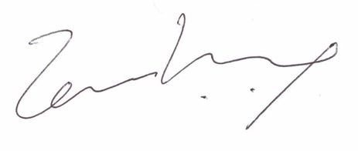
Temi Kolawole
Managing Director

